**Rethinking Rubbish!**

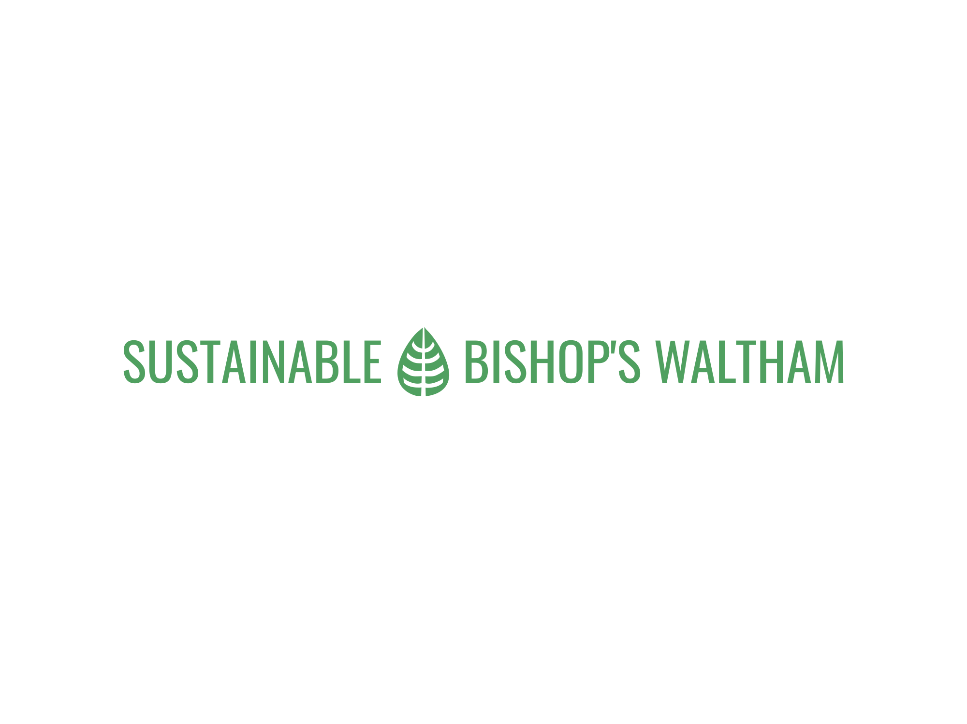





**Up-Cycling Competition 2025**

We are looking the most innovative creation made from up-cycled materials, especially those that would otherwise be destined for household waste. **The Criteria:**

We have a feeling that the standards will be high and judging will be tricky! So here’s a few pointers to help us make the final decision:

* How much waste has been diverted from landfill or incineration?
* What can you do with the newly repurposed object?
* How easy would it be for others to use this idea as a blueprint or template?
* If it’s a piece of art, how universally pleasing is it for everyone?
* If it’s too big to bring to Jubilee Hall, you can submit a portfolio.

**The Prizes:** Jamie’s Computers have donated **one prize** of a refurbished laptop for the most inspiring entry. Additional prizes to be announced. The competition will be judged at the ***Greening Showcase Celebration* on 11th October 2025** and announced at 12.00pm, and the judge’s decision is final.

**How to Enter:**

Enter the competition by completing this form and sending it by 4th October 2025 to:

* By email to: [wasteprevention@gmail.com](mailto:wasteprevention@gmail.com)
* Posting or handing this form into Bishops Waltham Parish Council Offices, Jubilee Hall, Little Shore Lane, Bishop’s Waltham, SO32 1ED.   
  Please mark the envelope: **“UP-CYCLING COMPETITION”.**

**And** bring your entry, or provide a portfolio of photographs if it is not portable, to Jubilee Hall on Saturday 11th October 2025 **at 10.00am.**

**Acceptance of Terms:**  By entering the competition, participants agree to the terms and conditions stated below:

**Up-Cycling Competition 2025 Entry Form**

|  |  |
| --- | --- |
| **First Name of Entrant:** |  |
| **Surname:** |  |

**Over 18 Under 18**

|  |  |
| --- | --- |
| **Title or Description of entry:** |  |

|  |  |
| --- | --- |
| **About your Up-Cycling entry** | |
| **What is your entry made from?** |  |
| **What can you do with the newly repurposed object?** |  |
| **Can you provide a blueprint or template for others to use?** |  |

**Please write a paragraph about your entry.**

**This will be printed and displayed next to it to explain what it is and how it meets the criteria of the competition. (Make sure that this does not identify you)**

**.**

**How big is your entry? Display space required cm x cm**

**Dimensions: Height: Width: Depth:**

**Table top portfolio of Photographs only**

**Email address:**

**Telephone / Mobile:**

### 

### ****Up-Cycling Competition Terms & Conditions****

**1**. Anyone can enter this competition regardless of where they live or their age. There will be a separate prize category for children under18 years of age at the time of entry.

**2**. Only one entry per person with a valid email address and telephone number. The entry form must be completed in full for an accepted entry submitted by 4pm Saturday 4 October 2025.

**3**. If you win one of the prizes, we will notify you by telephone and email, within 72 working hours of the judging date. The judges’ decision will be final, and no correspondence will be entered into.

**4**. The winning entry items are required to appear in the competition photos and or video, together with the names of the winners.

**Photo Permissions:** We would like to have photos and or videos of you as well. Please sign the box below to provide permission for photos and videos of you to appear in our publicity, including websites and social media. Please state if you are signing on behalf of a child as a parent or guardian.

Signature: On behalf of:___________________________

**5**. No part of a prize is exchangeable for cash or any other prize.

**6**. Sustainable Bishop’s Waltham and Bishop’s Waltham Parish Council will endeavour to send prizes within a month of the competition end date but cannot guarantee this delivery. Prizes will only be delivered to UK residents.

**7**. Sustainable Bishop’s Waltham and Bishop’s Waltham Parish Council can withdraw this competition or amend the terms and conditions and prizes at any time.

**8**. Sustainable Bishop’s Waltham and Bishop’s Waltham Parish Council will only use the names of winners in reference to the competition within the ‘Up-Cycling’ competition photos / video, and websites (<https://www.greeningbishopswaltham.uk/>) and social media channels.

**9**. Your data will be held securely by Sustainable Bishop’s Waltham and used solely for the purposes of this competition. Your data will be deleted once winners have been selected and the prizes distributed.

**10**. Your contact data will not be shared with any other third parties and in line with point 9, you can unsubscribe at any time by emailing admin@bishopswaltham-pc.gov.uk

**11. Liability: Sustainable Bishop’s Waltham and Bishop’s Waltham Parish Council cannot accept any liability for the entry while on display at the event. Entrants must ensure that the item is not hazardous to members of the public. Any item entered that is deemed a hazard may be removed at the sole discretion of the organisers.**

**12. Governing Law:** This competition will be conducted in accordance with English law.

**13. Acceptance of Terms:**  By entering the competition, participants agree to these terms and conditions.

**Data Protection and Opt In for Emails:** All contact details are held by Sustainable Bishops Waltham, a sub-committee of Bishops Waltham Parish Council, for the purposes of notifying the winners of this competition only. You will be sent an email after the competition with details of the winning entry. After which, all details and emails will be deleted unless you tick this box to say that you would like to continue to receive email updates about our work. You can unsubscribe at any time by emailing admin@bishopswaltham-pc.gov.uk.

I would like to continue to receive email updates about the work of Sustainable Bishop’s Waltham: